Transmeta Crusoe

February 1, 2001

Group 23

Todd Goldfinger
Tom Schneider
Daniel Wilhelm
Josh Martin

The Idea

Transmeta created the Crusoe by combining the inherent efficiency and parallelism of VLIW with the concept of dynamic binary recompilation. Essentially, the Crusoe removes the complex task of decoding and scheduling instructions into software. However, running this Code Morphing Software simultaneously with the application software reduces the performance. To make up for this, the Crusoe uses a very simple, high speed VLIW engine. Benefits of this approach include the elimination of large areas of the chip, which enables the die to be smaller, feature fewer transistors, and run cooler.

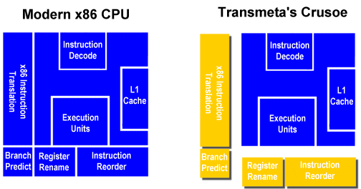
Figure 1. Hardware (blue) vs. Code Morphing Software (yellow).

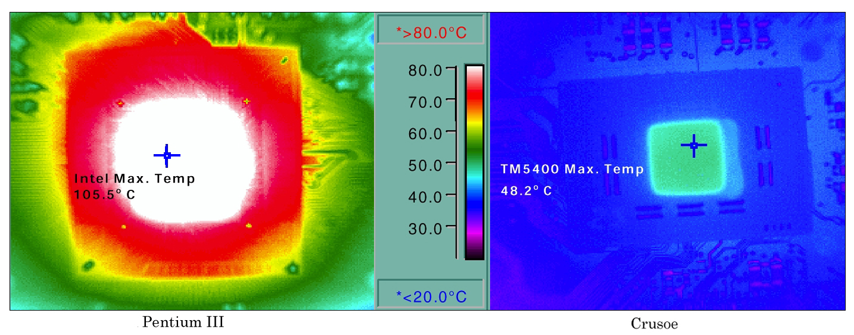
Figure 2. Heat generated by a Pentium III and a Crusoe playing a DVD.

In the past there have been several attempts to use dynamic binary recompilation, however these were burdened by high emulation overhead. The power of the Crusoe comes from its ability to emulate hardware while only loosing about 25% in performance. However, this emulation also causes code-bloat that will take up space in main memory, I/O bus, and reduces the effectiveness of the caches. Converting x86 into VLIW may expand the code 33-100%, even if the instruction ratio is the same. Considering the examples given by Transmeta, another 50% might need to be added for the extra sub-instructions and NOPs required to do the same work as the x86 code.
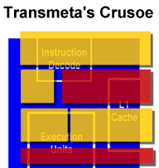
Figure 3. Code Morphing Software (yellow) running with OS and application software (red).

Crusoe’s Hardware

The Crusoe register file contains 160 physical registers. Which include 64 General Purpose Registers that are 32-bits wide, support partial-register writes, and are backed up by 48 shadow registers as well as 32 Floating Point Registers that are 80-bits wide, support x86 extended precision floating-point operations, and are backed up with 16 shadow registers. The Code Morphing Software allocates these registers to hold either unconverted x86 state, state internal to the system, or temporary registers.

The Code Morphing Software is a dynamic translation system written in native Crusoe code. It is stored on a special ROM, but it copies itself into DRAM when the system initializes. Once the Code Morphing Software is running, the OS and applications may be loaded on top of it. These ROM chips might need to be updated with new Code Morphing Software if a serious bug is a found or new feature added. However, precautions must be made to make it hard for viruses and other malicious programs to wipe it out.
The native instruction set can be changed arbitrary by altering the Code Morphing Software, without affecting any higher-level programs. This allows problems or design issues to be fixed in software, instead of hardware. Traditionally, when an instruction set architecture is changed on a VLIW machine, the old binaries would have to be recompiled. There is also a related problem on x86 machines; old applications also need to be recompiled to take full advantage on the new processor implementation. However, the Crusoe always transparently “recompiles” and optimizes the x86 code it is running.

“Crusoe does for microprocessors what Java does for software: it interposes an abstraction layer that hides internal details from the outside world.” Java works by interpreting special byte codes into native machine code; these byte codes are then executed by hardware. Crusoe does essentially the same except that the byte codes are native x86 instructions or instructions from some other architecture. Also, Java runs at the operating system level; Crusoe runs at the hardware level and interprets the operating system. Also, Transmeta demonstrated that Java byte codes can be compiled directly to native Crusoe code; this would be a huge speedup.

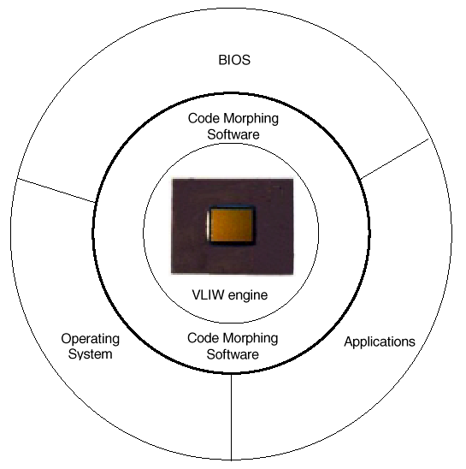
Figure 4. The Code Morphing software mediates between x86 software and the Crusoe processor.

Code Morphing Software

The software can “morph” an entire group of x86 code at once, creating a translation, which is stored in a translation cache. Using that cache, the Crusoe can skip the translation step and directly execute that optimized sequence of code the next time. A novel approach when compared to a normal superscalar x86 processor, which translates each instruction every time it is executed.

Furthermore, blocks of code repeated often, like those in loops, run faster with the optimized translation waiting in the cache. However, some common benchmarks that perform a variety of tasks once do not account for initial overhead and the following benefit. An inaccurate test, considering that as a program executes, the Crusoe learns more about it and optimizes so that it will execute faster and faster.
With the right Code Morphing Software, the Crusoe can translate any given instruction set (x86, PowerPC, Alpha, etc.) into native Crusoe code. The current Code Morphing Software translates all x86 instructions, except the SSE and 3DNow! extensions, into either 64-bit or 128-bit VLIW called a molecule. Where each molecule contains up to 4 RISC like instructions called atoms. The arrangement of the molecule determines how atoms get routed to functional units. If a molecule can’t be filled entirely, it is padded with NOPs. Transmeta ensures that no molecule will ever have more than one NOP. . There are 6 different ways to bundle up instructions into VLIWs each of which can contain up to 4 RISC like instructions.

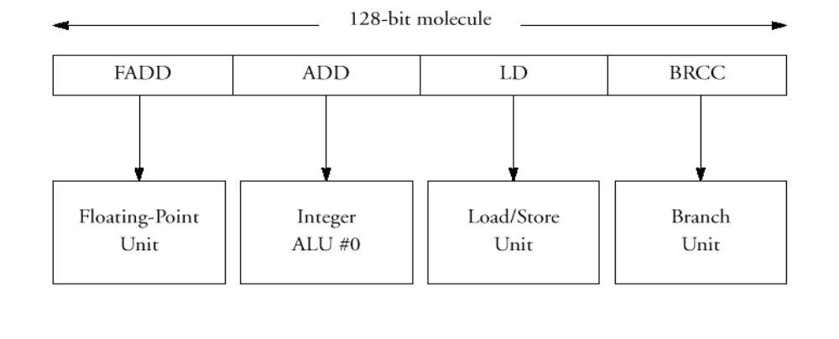
Figure 5. A molecule can contain up to four atoms, which are executed in parallel.

Filtering

In most applications, a small percentage of the code gets executed a majority of the time. Considering this, the translation system should scrutinize the common code and not give too much importance to code that is run once. The code morphing software allows a range of optimizations from interpretation (no translation overhead, but executes x86 code more slowly) to fully optimized code (takes longer to generate, but runs the fastest).

The Crusoe determines what level of optimization to use through a set of heuristics based on information gathered while executing the code. Some of the runtime information is gathered through special code that is added by the translator. The only purpose of this code is to collect various information such as the block execution frequency and the branch history. Similar information would be difficult to obtain at runtime in a traditional x86 processor. Because Crusoe does its branch prediction in software, it can look at larger blocks of code, and achieve much higher accuracy levels with branch prediction in general.
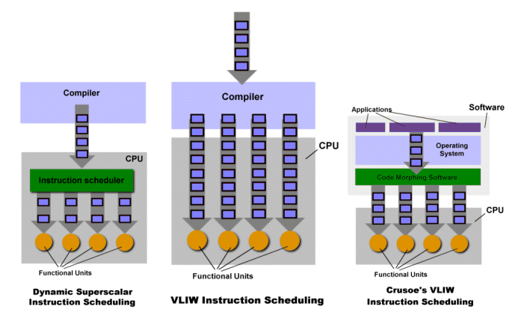
Figure 4. Approaches towards parallelism
Left: The program is compiled and the CPU schedules code dynamically at runtime. The instruction scheduler can chose from 4 pipelines and functional units.
Middle: At compile time the instructions are put into VLIWs so that no scheduling is necessary at runtime.
Right: This is Crusoe's approach. The various applications have already been compiled and are running on top of the operating system. The operating system itself is also running on top of the code morphing software. The code morphing software translates the executing instruction set into native Crusoe code, schedules the code, and places it into VLIWs for the hardware to execute in its functional units.

Translation
After the filtering and path selection algorithms choose several x86 instructions to translate, they are processed through several steps. First, the frontend of the translation system takes each instruction and converts them into the equivalent atom. Second, the optimizer goes through the atoms looking for well-known optimizations such as common subexpression elimination, loop-invariant code removal, loop unrolling, and dead code elimination.
Traditional computers cannot do dead code elimination at runtime because hardware can't look at large blocks of code at once. However, this is not to say that a good optimizing compiler can't get rid of redundant or unnecessary code. But, Crusoe can also break more complicated x86 instructions into smaller RISC instructions, possibly removing unnecessary memory accesses, which would be required on an x86 architecture. So the optimizer can actually eliminate unneeded atoms. Finally, the scheduler creates the molecules by reordering the remaining atoms for maximum parallelism.
Some issues to note: the software arranges the x86 instructions in the molecule out of order to directly encode the instruction-level parallelism; however, each molecule is executed in-order by the hardware. Hence, a very fast and low power VLIW engine can execute them.

Hardware support for dynamic translation

Exceptions and Scheduling
Without special hardware support, it’s challenging for a dynamic translation system to correctly model the exception semantics because of the severe constraints on instruction scheduling. In particular, x86 has precise exceptions, so that when an exception occurs, all instructions prior to it and none of the instructions after it are completed. A problem arises when atoms occur out of order. The individual VLIW instructions on Crusoe execute in order; however, as stated, the atoms packed into these instructions are not in order. This means that actual x86 instructions can be executed out of order. Intel's machines may start instructions out of order, but they always complete in order.

To solve this problem, all registers holding an x86 state are shadowed, or in other words, there is a working copy and a shadow (backup) copy of the register. All code modifies the working copies until a translation is complete. After that, a special commit operation stores the values in the working copies in the corresponding shadow copy. However, if an x86 exception occurs during the translation, all working registers are rolled back to their previous states, their shadow copies. Once the registers are back in their pre-exception state, the code is re-executed more conservatively, in the original order, to find the actual location of the exception. In fact, the code morphing software even has to emulate infamous Windows Blue Screen! If an error is caused which would invoke a blue screen on an x86 architecture running windows, that same error has to occur on Crusoe's chip to ensure identical results.

Optimizing Memory Operations
To undo changes in memory, the Crusoe uses a “gated store buffer” to hold the store data until it is committed to memory. In case of a roll back, the data is simply ignored. In general, the more freedom the scheduler has, the better the code it can generate. The problem is data/memory dependencies. There is alias hardware to solve this problem. For example, it would be very convenient to move a load ahead of a store. In that case, it changes the load into a load-and-protect instruction. This is similar to load, but the memory address and size of the loaded data is also stored. The store is changed into a store-under-alias-mask instruction; it's the same as the store, but it checks for protected regions. Whenever the load and store conflict, a Crusoe exception is raised and the runtime system fixes the problem. Keep in mind that a Crusoe exception is different from an exception caused by an x86 instruction. In this situation there would be no rollback. The use of this alias hardware also allows the elimination of redundant load/store atoms.

Dealing with self-modifying code
x86 instructions may get overwritten due to OS loading new program or self-modifying code. To prevent the wrong code, an old translation, from getting executed, the Crusoe write-protects the page of memory that contains the translation by setting a dedicated “translated” bit in the page’s entry in the processor’s memory management unit. Whenever a protected page is written to, the code on that page will have to be retranslated. This, of course, may make self-modifying code less efficient, which, depending on how you view this might be a good thing.

Code Example

Ld %r30, [%esp]
Add.c %eax, %eax, %r30
Ld $r31, [%esp]
Add.c %ebx, %ebx, %r31
Ld %esi, [%ebp]
Sub.c %ecx, %ecx, 5

This x86 code sequence is translated and scheduled as follows:

1) Ld %r30 [%esp]; sub.c %ecx, %ecx, 5
2) Ld %esi, [%ebp]; add %eax, $eax, %r30; add %ebx, %ebx, %r30

Notice that these instructions have been reordered and one load has been removed. This was accomplished by simply reusing the r30 register. (This code example is recreated from Ref. 1)

Analysis
The other highly desirable feature of Crusoe is its ability to compete with modern processors and still consume very little power. It is able to accomplish this feat by moving much of the hardware into software. The downside is that the software needs to be very efficient in order to execute code at a reasonable speed. There is actually a remarkably low emulation overhead, which is estimated to lose only 25 percent in performance. Keep in mind, though, that every program has to be interpreted and run through the code morphing software; the code morphing software is the only software that runs on native Crusoe code.
There are many tradeoffs involved in deciding what should go in hardware and what should go in software. To be efficient, the hardware and software must work together exceptionally well since they are so tightly bound. The current Crusoe processors rely heavily on software, but it is speculated that future processors may have a better mix of hardware and software.
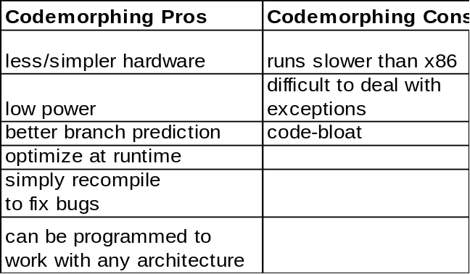

There are some benchmarking concerns with the Crusoe because it doesn’t quite fit into any existing categories. Some benchmarks with lots of repeated loops may over-estimate performance, while benchmarks that drive real applications with automated scripts my underestimate performance.

Transmeta is competing with Intel in the mobile and laptop markets. In doing so, they had to have a way to compete with a large company like Intel. Intel and AMD do not have low power consuming processor cores in the mobile market. This is where code morphing and low power consumption come into play. There are currently two different Crusoe chips. One is designed for mobile Internet appliances. The other is for windows-compatible notebook PCs. The first chip is the lower end processor and has a smaller primary cache and no secondary cache. For the most part, however, these two designs have the same architecture; they differ only in the caches and some other special hardware that is not a part of the CPU. Crusoe is slower than x86 chips running at the same clock rate. But this is because Transmeta optimized the morphing software for power efficiency not speed. So Transmeta is competing with Intel by overlooking the speed issue and looking at other soon to be very important computing issues.

[1] Klaiber, Alexander. The Technology Behind Crusoe Processors. Transmeta Corporation. (www.transmeta.com). January 2000.

[2] Hannibal, Jon. Crusoe Explored. Arstechnica. (arstechnica.com/cpu/1q00/crusoe/crusoe-1.html).

[3] Halfhill, Tom R. Transmeta Breaks x86 Low-Power Barrier. Microprocessor Reports. February 2000.

[4] Diefendorff, Keith. Transmeta Unveils Crusoe. Microdesign resources. January 2000.

